2006-Markov becomes the newest Holoknight

September 14, 2006
Dr. Vladimir Markov became the latest to be knighted into the International Order of Holoknights. The special knighting service was held at the banquet of the International Conference on Speckle in Nimes, France on Thursday, 14 September, 2006. Organized and headed by Dr. Pierre Slangen, a professor at the School of Mines, Ales, France, the conference was attended by top scientists in the field from around the world and convened from 13-15 September.
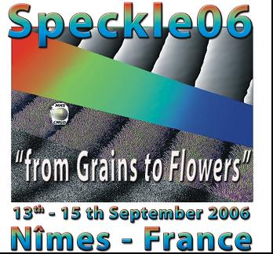
In keeping with the selection rules, Markov was selected from the top holographers in the world by Rajpal of Bhopal (Professor Rajpal Sirohi of Bhopal, India,) who was the holoknight inducted by the order in 2005, and was confirmed unanimously by the full council of holoknights. He was presented with a Holoknight sword and a parchment signed by attending holoknights. His new title is Vladimir of Kiev. The knighting portion of the service was conducted by Wolfgang of Berlin (Professor Wolfgang Osten), who heads the Institut für Technische Optik, Universität Stuttgart, Germany. Rajpal of Bhopal, who would normally perform this part of the service, was unable to attend.
Other holoknights in attendance were Werner (Juptner) of Bremen, Malgorzata (Kujuwinska) of Warsaw, Paul (Smigielski) of Alsace, Pierre (Boone) of Gent, Armando (Albertazzi) of Catarina, Mitsuo (Takeda) of Tokyo, and Rich (Preputnievich) of Massachusetts.
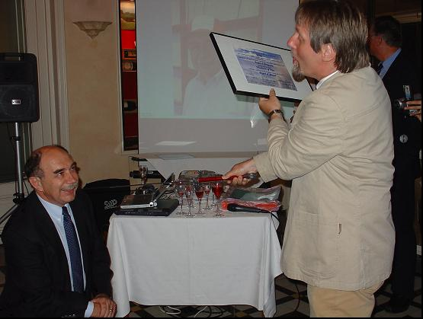

Photo property of Wolfgang Osten
Wolfgang of Berlin knights Vladimir of Kiev-The parchment and sword, held by Wolfgang, were then given to Vladimir, the latest holoknight.
Dr. Markov Pioneered the study of the basic properties of volume holograms recorded with random amplitude-phase (speckle) encoded reference beam which leads to ultra high-density data storage in volume hologram recording with speckle-shift selectivity. Dr. Markov also did extensive study and performed the first experiments with two- and four-beam coupling in a resonant medium (sodium vapor). He demonstrated the possibility of extremely high gain for signal beam amplification. He was first to propose the possibility of applying the optical double-transform Fourier
In 1994, Markov established and became the first Director of the Institute of Applied Optics of the National Academy of Sciences of Ukraine. In 1995 he became the director of the Institute of Optics of Bogota (Columbia). In 1998 he joined MetroLaser Incorporated, Irvine, CA and is currently a vice president and the head of the Applied Optics Group. He was a close friend and associate of Professor Yury Denisyuk, one of the fathers of holography, who passed away in June, 2006. He gave a memorial talk on Denisyuk at the Speckle 06 conference.
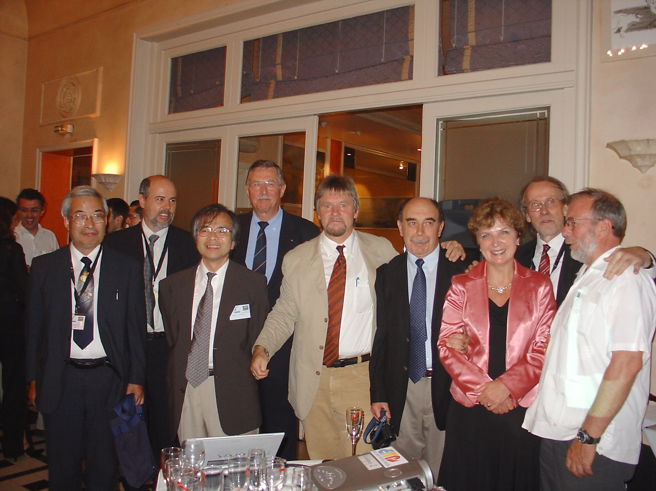

Nine Holoknights in Nimes
